**Chapter 4 System Design**

The proposed model will make use of GPS hardware, already existing in most smart phones, to receive and transmit GPS signals. These signals are transmitted to a central server which can communicate to traffic signal controllers via Internet. The model consists of 3 main components as depicted in Fig. 3.

* An Arduino Microcontroller at each traffic intersection with an Ethernet Shield to enable it to connect to the Internet.
* An Android Application for an Android Smartphone will have to be carried by the staff of each ambulance. This app will receive GPS coordinates and transmit the same to a web server.
* A Web Server which receives GPS coordinates of all emergency vehicles and then sends preemption signals to traffic signal controllers accordingly.

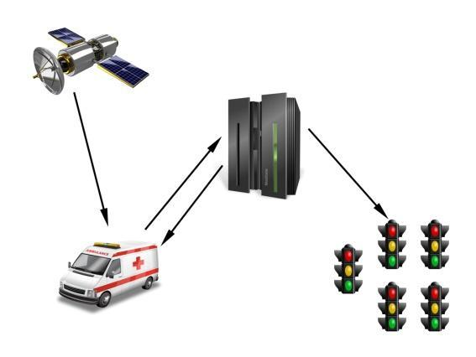

Fig 4.1 Main components of the proposed Model

4.1 **GPS**

GPS is a space-based satellite navigation system that provides location and time information during all weathers anywhere on or near the earth, where there is an unobstructed line of sight to four or more GPS satellites. Satellites are equipped with high-precision atomic clocks enabling them to measure time accurately. Receivers hold information regarding the position of any satellite at any given time. Thus, a precise position can be calculated by timing how long the signals take to reach the receiver from the satellites in view. By reading the incoming signal, the receiver can recognize a particular satellite, determine the time taken by the signal to arrive, and therefore calculate the distance between itself and the orbiting satellite.

4.2 **Arduino Microcontroller**

Arduino is an Open Source Hardware platform which consists of a programmable microcontroller development platform, expansion capability through add-on boards, and a programming development environment for creating custom microcontroller software. All circuit-board and electronic component specifications, as well as the programming software, are open-source and freely available for anyone to use or modify [3].

In simple words Arduino is a small microcontroller board with a USB plug to connect to your computer and a number of connection sockets that can be wired up to external electronics, such as motors, relays, light sensors, laser diodes, loudspeakers, microphones, etc. They can either be powered through the USB connection from the computer or from a 9V battery. They can be controlled from the computer or programmed by the computer and then disconnected and allowed to work independently.

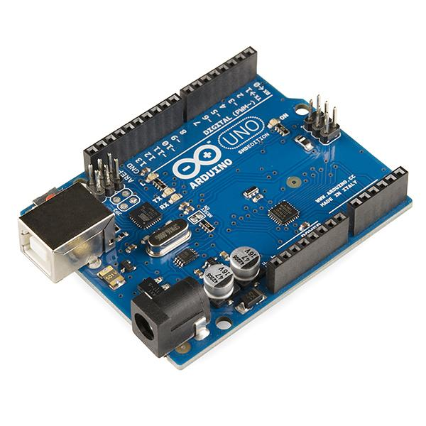

Fig. 4.2 Arduino Uno [3]

The Arduino board is designed to allow expansion through the connection of auxiliary boards or shields. The shields connect via mating pins which are arranged in the same physical configuration as the Arduino board, and simply plug onto the headers on the top of the Arduino board. The shields are then controlled by the Arduino microcontroller and program, which access the shields’ pins through the Arduino pins. Programming libraries allow users to quickly integrate new devices and sensors into projects without requiring writing of extensive new program routines. Some examples of Arduino shields are Arduino Ethernet Shield, Wi-Fi Shield etc., that allows the board to connect to the internet and be networked with other devices[4].

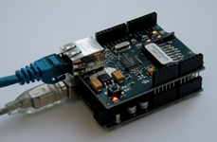

Fig. 4.3 An Arduino Ethernet Shield mounted over an Arduino Uno [4].

4.3 **Webserver**

The primary function of a web server is to deliverweb pages and files, on request toclients, using theHypertext Transfer Protocol (HTTP). The web server in the proposed model will perform the following functions:

* Will accept login authentication requests from android device app.
* Will accept emergency status requests from android app.
* Accepts and monitors geo-coordinates of declared emergency vehicles in a database on the server.
* For each emergency vehicle, the closest approaching traffic signal is computed.
* Preemption commands are sent to the corresponding traffic controller.
* Commands are also sent to the traffic controller, to return to normal mode once the emergency vehicle has passed.
* Maintains logs and statistics of preempted signals, emergency vehicles etc.

4.4 **Android Application**

Android is a software stack for mobile devices that includes an operating system, middleware and key applications. By providing an open development platform, android offers developers the ability to build extremely rich and innovative applications. Developers have full access to the same framework APIs used by the core applications. The architecture is designed to simplify the reuse of components. Any application can publish its capabilities and any other application may then make use of those capabilities (subject to security constraints enforced by the framework). This same mechanism allows components to be replaced by the user. The Android SDK provides the tools and APIs necessary to begin developing applications on the Android platform.

The proposed model will use an android application which will be used on a smartphone or tablet installed in every ambulance. The app will use the Location Manager, and Location Provider to perform the following functions:

· The app can only be accessed using a secure web based login.

· The staff can select a priority level and request an emergency status.

· Once the vehicle is declared as an emergency vehicle, the app will send regular updates to the server, which consists of the geo-coordinates of the vehicle, obtained using GPS Location Manager.

The state transition diagram for the App is shown below.

<DIAGRAM>

**4.5 Sequence Diagram**

A typical sequence of events that occur, and interactions between the main components is shown in the sequence diagram.

<DIAGRAM>

**4.6 Users and Use-case diagram**

The main users of the system are:

* Ambulance Staff
* Webserver Administrator

The following components can also be considered as users, since they require data and services from other components:

* Android App
* Arduino Microcontroller
* Web Server

The usecase diagram for these users is shown below.

<DIAGRAM>